Enterprise Statement:

This database will be a public tool that anyone can access in order to gather information or research. The database will include data about trees and their characteristics such as bark type, leaf type, height, etc. The database will also show if the trees produce any fruit or nuts then provide information about them as well. There will also be information about different biomes such as amounts of rainfall, locations, and temperature data. These two sections can be used to compare information about tree and biome data for whatever purpose the user may need it for.

ERD:

Relational Schema:

Dependency Diagrams:

Tree:

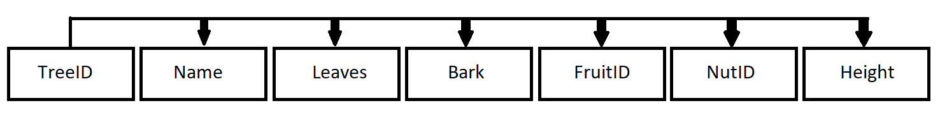

Fruit:

Forest:

Normalization:

My Trees and Biomes database is in third normal form as seen in the above dependency diagram section. In my database there are no repeating groups within the tables and they all have a primary key which passes the first normal form test. It also passes second normal form because there are no partial dependencies in the diagrams. Finally, since all of the diagrams show that there are no transitive dependencies in the tables this means that my database is in third normal form.

Queries:

Q1: What are all of the fruit producing trees and their fruit in the tropical rainforest biome?

Q2: Are there any trees that live in more than one biome?

Q3: Which trees produce cones?

Q4: What is the information for medium height trees in North America?

Q5: What location and biome is the Baobab tree in?

Q6: What is the average annual rainfall of all the biomes?

Q7: What are the location names and biomes in North America?

Q8: What is the most common tree leaf and bark combination?

Q9: On average how much colder is the taiga than the temperate forest?

Q10: What tree does the Durian fruit come from?

Complexity:

The complexity of this database can be seen in the data that populates the database and the queries that access it. The database is made up of all real data that can actually be used to find information about the trees and biomes that are in it. Every link between what trees are in what biome in the Forest associative table is accurate. Also, there are at least five entries in every table so that there would be plenty of data in the database to write queries about.

The complexity of the queries lies in how they are constructed. Since the database is composed of two sections linked together by an associative table, comparing data from both sections can be tricky. The queries often had many joins and subqueries within them in order to achieve the desired effect. Also multiple queries used aggregate functions such as Count() or Max() to get the requested result which was a challenge considering the many subqueries mentioned before.